The Gristmill Gazette
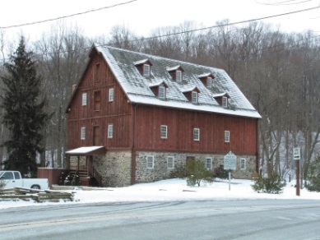
Jerusalem Mill Village
News & Notes
Winter 2020

2811 Jerusalem Rd., Kingsville, MD www.jerusalemmill.org 410-877-3560

Upcoming Events

All activities are in the village, unless otherwise indicated.

Saturday, February 8th: 9 AM ‘til noon: Second Saturday Serve Volunteer Day. Come help us with a wide variety of tasks throughout the village. All tools, materials, equipment and protective gear will be provided. We’ll meet on the porch of the General Store or in the Tenant House across the street from the store, depending on the weather. Everyone is invited.

Saturday, March 14th: 9 AM ‘til noon: Second Saturday Serve Volunteer Day. Come help us with a wide variety of tasks throughout the village. All tools, materials, equipment and protective gear will be provided. We’ll meet on the porch of the General Store or in the Tenant House across the street from the store, depending on the weather. Everyone is invited.

Sunday, April 5th: Easter Egg Roll (an old- fashioned American tradition), 1 PM to 4 PM. The Easter Bunny will be there, and you might see a variety of characters in colonial attire! There will be indoor activities in the Visitor’s Center if it rains.

Saturday, April 11th: 9 AM ‘til noon: Second Saturday Serve Volunteer Day. Come help us with a wide variety of tasks throughout the village. All tools, materials, equipment and protective gear will be provided. We’ll meet on the porch of the General Store or in the Tenant House across the street from the store, depending on the weather. Everyone is invited.

Details on all of our events are available on our web page at www.jerusalemmill.org or the Jerusalem Mill FaceBook page.
Save the Date

Our Annual Spring Dinner is scheduled for Saturday, May 2nd, 2020, when we’ll be celebrating the 35th anniversary of the establishment of the Friends of Jerusalem Mill and the 25th anniversary of the opening of the Jerusalem Mill Visitors Center and Museum. A highlight of the celebration will be a special presentation of the lifetime achievements of Harry Sanders, the founder of the Friends of Jerusalem Mill. Please mark your calendars and come help us celebrate all that Harry has done for Jerusalem Mill and the community. More details will follow in our spring edition of this newsletter.
Historic Anniversaries

Rebeckah Sackett was born 275 years ago, in Bucks County Pennsylvania, where she would later meet fellow Quaker, David Lee. They married in 1767, before moving to Baltimore County, Maryland to build a large grist mill for Isaiah Linton, along the banks of the Little Gunpowder Falls (it became part of the new Harford County in March 1774). Rebeckah and David Lee had five children, one of whom was Ralph Sackett Lee, who would later inherit Jerusalem Mill.

The miller’s house in Jerusalem Mill Village was built 250 years ago, and is the oldest surviving structure in the village. According to oral tradition, the building was once used as a shop to manufacture walnut gunstocks and assemble rifles for the American Revolution. Evidence also indicates that the building has been used as a Cooper shop, producing barrels for the grist mill, and even served as a cider kitchen with a large cider press to process apples. Most often, the building was used by the family that operated the mill, and later by various tenants. One family that lived in the house was the Ewing family, ultimately a family of seven before they outgrew the tiny house and moved next door into a barn that had been converted and expanded into a home (now known as “the Carriage House”). One of the Ewing boys who was born in the stone house was named after the builder of the mill. Coming “full circle”, David Lee Ewing became one of our docents in 2018! The Miller’s House is open on Sundays from 1 p.m. to 4 p.m., when you can watch living history interpreters demonstrate open hearth cooking, gardening, sewing or other activities of daily life in Colonial times.

This year we also celebrate the 175th anniversary of the construction of the springhouse. Built right over a natural spring, the small building maintains a year-round temperature of about 56 degrees. The springhouse was used to store perishable dairy products and other food items. The springhouse is often open on Saturdays from 1 p.m. to 4 p.m.
In the Spotlight:

Gold Award and Eagle Scout Programs

The Friends of Jerusalem Mill is very proud to support the Girl Scout Gold Award and Boy Scout Eagle Scout programs. These programs represent the highest levels of leadership and accomplishment within their respective organizations. Jerusalem Mill Village benefits from this program with the completion of an important project and the encouragement of local youth to volunteer their services while practicing their leadership skills. The candidates benefit by completing a challenging requirement toward high-level recognition within their program, and they develop a feeling of accomplishment and philanthropy.

As defined by the Girl Scout organization, “To earn this unique award, Seniors and Ambassadors don’t just change the world for the better, they change it for good by tackling issues dear to their hearts while driving lasting change in their communities and beyond.” To earn the Gold Award, girl scouts must identify an issue, investigate it thoroughly, build a team to help tackle the issue, create a plan, present their plan and gather feedback, lead their team to carry out the plan, and educate and inspire by telling their story and sharing their results.

To earn Eagle Scout, candidates must also plan, develop, and give leadership to others in a service project helpful to any religious institution, any school, or their community. Like the Gold Award, the purpose of the Eagle Scout service project is to learn leadership skills, or to improve or demonstrate leadership skills the candidate has already developed. The scout learns important lessons in project management and taking responsibility for a significant accomplishment.

Following are just a few examples of the many projects completed by Girl Scouts and Boy Scouts over the past few years, as described in their own words.
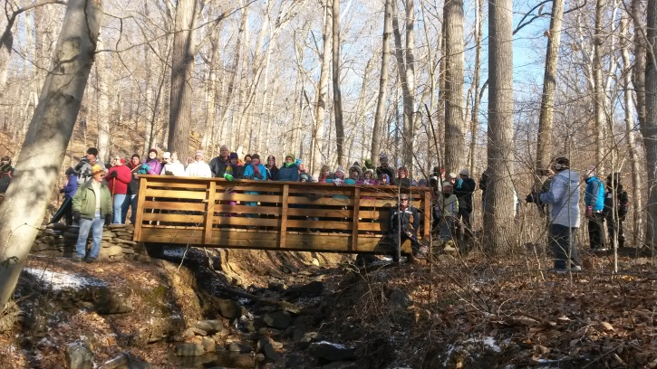
“My Girl Scout Gold Award Project was the first of its kind at the Mill. Not only was it an extremely large project, but it was also the first Girl Scout Gold Award at the Mill. For my project, I designed, fundraised for, and constructed a 20-foot long pedestrian bridge one-third of a mile into the woods on one of the hiking trails. The bridge was built because a stream eroded away the bank of the small ravine, leaving a slippery, steep, clay-lined bank that was dangerous to traverse. Overall, I logged approximately 180 hours on this project, twice the required amount for the Gold Award, and was assisted by numerous volunteers from the Second Saturday Serve event at the Mill. This project taught me valuable leadership, time management, construction, and engineering skills which I am finding extremely useful as I study Chemical Engineering at Drexel University.” Marley Downes

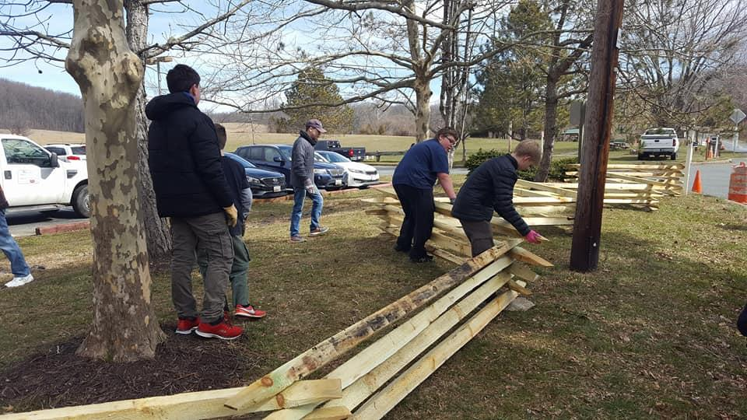
“In spring of 2018, I led a group of 30 Scouts who constructed a 200-foot-long split rail fence along Jerusalem Road. This project involved two parts – collecting rocks to serve as the foundation for the fence, and the actual construction of the framework of the fence. Since the fence was constructed, there has been a significant decrease in the number of pedestrians unsafely walking along Jerusalem Road.” Nicholas Marks

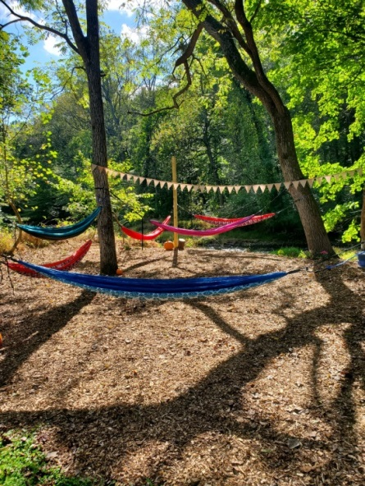
“Have you ever spent time in a hammock? Picture yourself swaying between two trees as you look up at the colorful sun-kissed sky that outlines the treetops. The crisp smell of fresh air blows by in the breeze. The river gently ripples over rocks and branches in the background. A bird chirps by as you lay enjoying the moment and soaking it all in. For my Girl Scout Award I created a Hammocking Park located behind the Miller’s House. I cleared out the area, installed posts, mulched, planted flowers and decorated the park. My passion for nature, hammocking and helping others was my inspiration. I created the park to provide a relaxing place for visitors to unplug and reduce stress. Guests can bring their own hammocks to the park or borrow one from the Visitor’s Center.” Kristen Ellington

Jerusalem Mill’s Intern Program

In 2018 the Friends of Jerusalem Mill revitalized its intern program, partnering with local colleges to provide history majors with an opportunity to gain knowledge and experience through practical application. Our interns develop a better appreciation of the importance of preserving and presenting our country’s history, and an understanding that some of history is “interpretation” in the absence of verifiable evidence. In turn, we get valuable help with research into more details of the village’s past, the creation of new displays, and a better organization of our artifacts inventory. Our intern for the fall semester of 2019 was Brandon Kelly, introduced in our summer 2019 edition of the newsletter. One of the topics he researched was the “oral tradition” that our little stone house was once used as a gun shop, where craftsmen made walnut gun stocks and assembled rifles for the American Revolution. He also identified some of the furnishings in our artifacts storage, and developed a Cooper display for our Visitor Center – Museum. Here are some reflections from Brandon:

The Jerusalem Mill Gun shop: An Expedition into the Past
By: Brandon Kelly

Throughout my recent internship at Jerusalem Mill Historic Village, one of my assignments was to investigate the legend of the gun shop which is believed to have been in the two-story building now known as “the millers house”, located behind the mill. The legend of the gun shop states that David Lee, Isaiah Linton, Nathan Bond, Gittings Wilson, John Kidd, James Woods and blacksmith Edward Connard were charged by the Gunpowder Falls Monthly Meeting House for “learning the Art of War” because they manufactured black walnut stocks that would have been sold to the Maryland Militia or to the men who were going to join the militia who lived in the area during the Revolutionary War. The legend has been passed down through the years by mostly word of mouth and so far no concrete physical evidence has been found to show that the miller house was used to produce the guns or the wooden gunstocks.

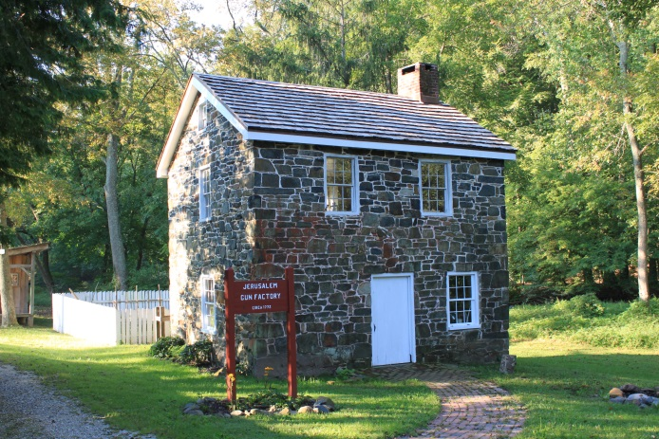
After traveling to the Maryland State Archives in Annapolis, MD, I found the original meeting house minutes of the Gunpowder Falls Monthly Meeting House attended by the men believed to have made the guns. These documents actually mention all of the men’s names who were involved in the gun shop legend in the year 1776, which was believed to have been one of the years that the events of the gun shop took place. Not all of the names of the people believed to have been involved were charged with learning the art of war, but some actually were documented, and it also said why they were charged. For example, The Gunpowder Falls A former “Gun Factory”?
Monthly Meeting Minutes of 1768-1784, pg. 329 states that John Kidd and Gittings Wilson had guns “and continued to join, and practice in the military operations”. The two mentioned in this passage were believed to have been involved in making the gunstocks and it is explicitly stated that they bore arms, and that they joined in the militia. Although not directly stating that there was the production of guns or gunstocks in these documents, it does provide evidence of the strong patriotic feelings within the Gunpowder Falls area and in particular at Jerusalem Mill. This is because several other individuals being charged with learning the art of war, bearing arms, etc. by the Quaker elders are also mentioned in other pages during the same year. This evidence provides the speculation that if all of these men were willing to fight in the Revolution and to join the Maryland Militia, then there would be a strong demand for firearms in the local area. This would create a business opportunity that David Lee and the others would not miss out on because they could make money and contribute to the cause of American independence. Even though it is only speculation, why would these people who lived in a Quaker village want to join a militia to fight in a war? Why risk their social status within the Quaker church and put their lives on the line? In order to answer these questions, one must understand how much these people cared about their cause. This patriotism is what caused these brave individuals to learn the art of war and bear arms. We do know for certain that despite their best efforts, John Kidd, Nathan Bond, and Gittings Wilson were caught by the meeting house and charged with learning the art of war.

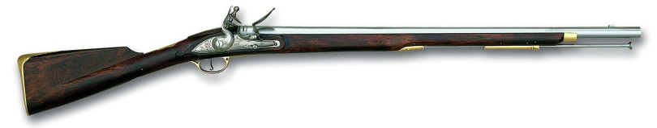
“Brown Bess”, a musket in use from 1722 to 1838

It is interesting that the documents do not mention David Lee or Isaiah Linton being involved in these cases, but it does mention Lee’s name as well as Nathan Bond and Edward Connard years later after the incident, showing that they were still involved at the meeting house even though Bond was definitely charged in 1776. If these men were involved then why would they have been allowed to stay at the same meeting house for years after getting caught? Were Lee, Linton, and Connard really involved in the gunstock making at all? Did their punishments end and were they allowed to attend the meeting house again? We may never know. What we do know is that the documents that have been examined reveal an insight into the past about the local community of Jerusalem Mill, because even though the Quakers believed in non-violence, those who wanted to fight were willing to support a cause they thought was worth the risk. That risk includes losing their social status at church, losing their lives, and their future. This specific revelation into the mindset of the Maryland patriot gives the audiences of today an understanding of how much those who came before really loved this country and how much they were willing to sacrifice for it.

Of course, I could not have created any of these theories or learned how to interpret historical documents without the support from the staff of the Friends of Jerusalem Mill. Everyone was so nice and supportive that it made me feel grateful to be a part of such an amazing team of dedicated volunteers. At the beginning of my internship I believed that if you looked deep enough into the research you would find a clear answer to what you were looking for. What I found out was that research is not black and white but is more like a shade of grey based on taking what evidence you have and interpreting that evidence to understand the past more clearly. A big help during my internship was the curator of Jerusalem Mill, Rich Albright, who gave me a lot of advice on researching documents and how to examine and interpret historical research in order to present our findings to the public in a way that reflects not only the story itself, but the people who lived through it as well. I also had the opportunity to volunteer for a couple docent shifts in the Museum-Visitor Center and I was impressed to see how much passion and knowledge the volunteers have about the village and the history that they bring to life. They are able to present that knowledge in a way to not only educate but to bring the history alive. The docents and other volunteers have worked so hard to make Jerusalem Mill Historic Village what it is today. I would personally recommend browsing through one of the scrapbooks they have in the Visitor Center to see how much restoration they have done to the Mill and the entire Village is absolutely breathtaking. All of the volunteers give it their all to help bring a little corner of our state’s history back to life and they are happily willing to share all that they’ve learned about such an amazing and beautiful historic village.
Jerusalem Mill Village in Miniature

The Jacksonville Senior Center presented their annual Holiday Christmas Garden, from December 9th through December 29th. A special feature this year was a portion of the Jerusalem Mill Village, in miniature and to scale. It included a well-crafted model of our grist mill, miller’s house, blacksmith shop, wheelwright “ghost frame”, covered bridge, and one of our vintage baseball games.

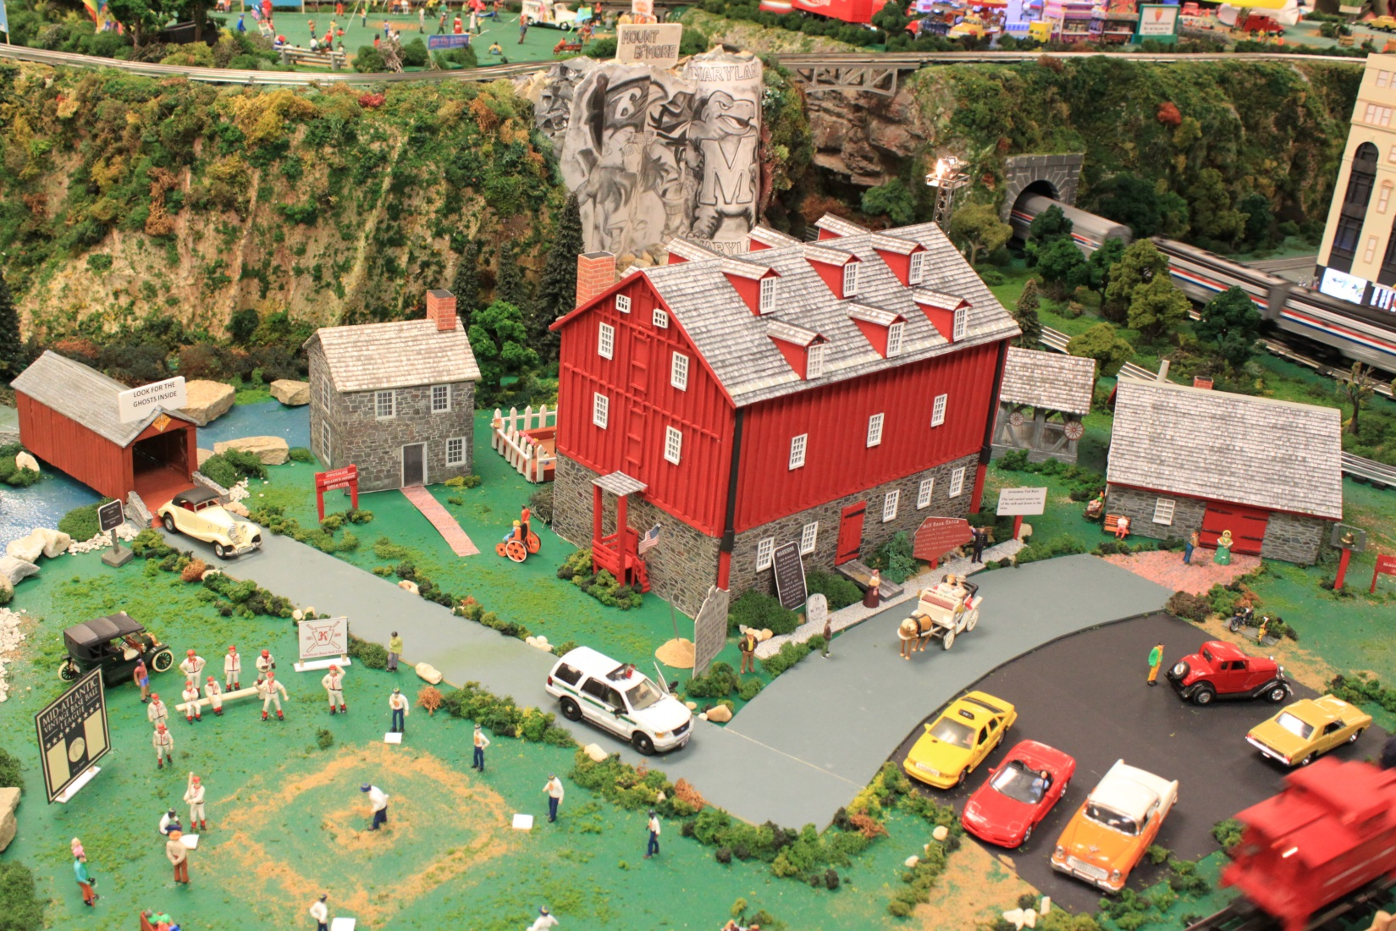
In Memoriam

We are sad to report the passing of the husband of our docent Mary Ellen Haisfield-Wolfe in October. Bob Wolfe was a mechanist and draftsman, and enjoyed many hobbies such as poetry, astronomy, and writing Op-Ed pieces for the paper. He was a friend of the Towson Unitarian Church. His ashes will be buried at Green Lane Cemetery in Capon Bridge West Virginia in the spring, as is the family tradition. Our thoughts and prayers are with Mary Ellen.
First Day Hike

On the first day of each New Year, Maryland state parks host a “First Day Hike” to encourage residents to start the year off with exercise, fresh air, a break from technology, and the enjoyment of Maryland’s natural resources. The Friends of Jerusalem Mill partners with the Gunpowder Falls State Park rangers to host the event on the trails around Jerusalem Mill Village. Registration and refreshments were available in the blacksmith shop (as well as heat from the authentic wood stove) prior to the hikes that started at 10 AM and 2 PM. This year we set the attendance record for Maryland State Parks with just over 500 participants hiking the approximate 1.5 mile “loop” from the village, west along the Jerusalem Mill Trail then back along the Little Gunpowder Trail on the banks of the Little Gunpowder Falls. The weather was absolutely perfect for the event. Special thanks to Jerusalem Mill’s Rick Decker, park Ranger Andrea Bucher, and the Maryland Conservation Corps team who served as trail guides.
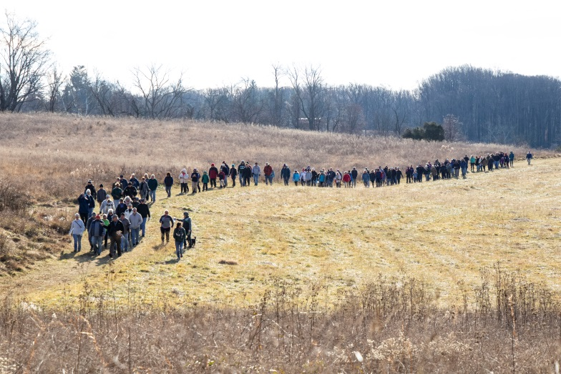
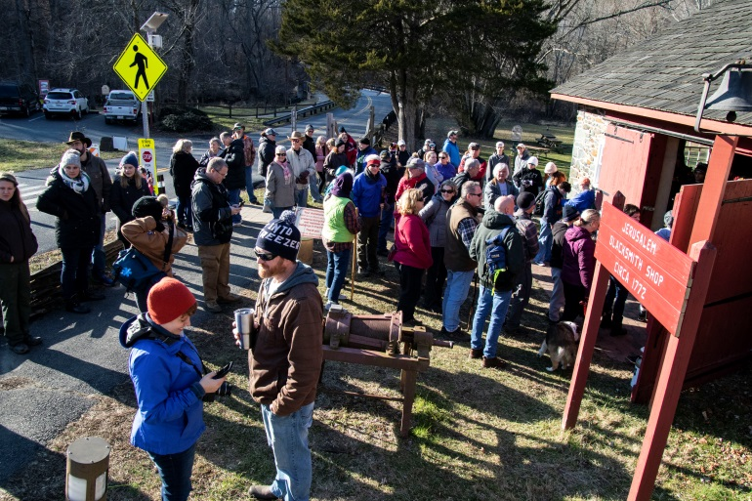

Registration and refreshments prior to the hike. First Day Hike 2020.
Photos courtesy of photographer Jack Benesch.

Meet Our Volunteers

Each quarter we’ll introduce you to one of our volunteers. As a non-profit charitable organization, with no paid staff, we greatly appreciate our dedicated volunteers. We want to share their stories with you.

Steve Nobles is our newest docent, working in the Visitor Center – Museum sharing the rich history of the village with visitors from all over the world. Steve grew up in Miami, Florida, and then moved to Pittsburgh just before his teen years. He served in the Army as a medic during the mid-1970s, then worked as an aircraft mechanic after he returned to civilian life, and eventually went to college to become a teacher. Steve retired last year, after teaching History, Geography, and some Math in middle school for 27 years. He also coached Cross Country and Track & Field in the 1990s. He was a competitive runner and cyclist in the 1980s and 1990s, and still enjoys those activities today. His fondness for Jerusalem Mill is the result of spending many hours running the trails and fishing the river in and around the village.

Thanks to Steve we have added Thursday mornings to our expanding Visitor Center – Museum
Schedule, as he opens every Thursday from 10 AM until 1 PM. He also helps us on weekends, filling in as much as possible. Stop in and meet Steve, and chat about village history, running, cycling, reading, geocaching, teaching, fishing and gardening.

We Need Your Help

Because The Friends of Jerusalem Mill is a non-profit charitable organization, we rely on generous donations of time and money from our many volunteers and donors to accomplish our mission of preserving and presenting local history. Let us know if you have some time to spare and can help us continue our mission. Here’s just a sample of some of the volunteer opportunities:

Docents: Greet visitors and guide them through the visitor center/museum, the general store, or the Civil War Room. Provide information about the history and operation of the village and answer questions about the park. No prior knowledge of the village history or details about the park is required. Our Volunteer Handbook has all of the information you’ll need.

Special events: Plan and organize. Collect tickets/admission, set up chairs, tables, canopies, etc., direct parking, assist pedestrian crossings, guide visitors, tear-down, etc. This can be a year-round or one-event commitment.

Research/Curatorial Assistants: Identify and inventory artifacts; perform various research projects online, at historical societies and archives; create displays, etc. Focus areas include genealogy, architecture, archeology, history and sociology.

Living History Interpreters: Wear era-appropriate attire, share knowledge of various aspects of life in the 18th and 19th century. Most immediate need is for a carpenter/woodworker, toy demonstrator, cooper, tinsmith, gardeners/farmers, colonial cooks, tour guides.

Grant writers: Help us manage our grant program by preparing grant applications for a wide variety of projects and purchases. Maintain a calendar of deadlines to ensure we don’t miss an opportunity or obligation. This function can mostly be performed at home or office!

Village Maintenance and Repairs: Second Saturday Serve is a year-round, monthly event open to volunteers of all ages, on the second Saturday of every month, from 9:00 a.m. until noon, to perform a wide variety of tasks. Just show up and we’ll put you to work!

Lawn Service: From late April through October we cut grass (riding mowers and walk-behinds), trim around buildings and fences, weed gardens, etc. once per week, usually on Wednesday or Thursday. We can use your help every week, once-per-month, or however often you can!

Web Master: Help us keep our web pages up-to-date. This is another function that can be performed at home or office.

Trail maintenance: Hike the wooded trails of the Gunpowder Falls State Park Central Area and pick up trash, remove debris from the trails, trim overgrowth, and report downed trees and other hazards to the park office.

Donations: Financial contributions can be made through membership, business sponsorship, renovation and maintenance fund contributions (cash, check or through PayPal at https://www.paypal.me/jerusalemmill), or by selecting the Friends of Jerusalem Mill as the charity of choice when you purchase through AmazonSmile (smile.amazon.com). Yard sale donations can be made during Visitor Center hours (see next page). Items accepted for yard sales include household goods, toys, books, tools, hardware, small furniture, decorations, family friendly CDs and DVDs, etc. – please no clothing, chemicals or food items.

Jerusalem Mill Village Living History Program, 2019
All times listed above are subject to the availability of volunteers.

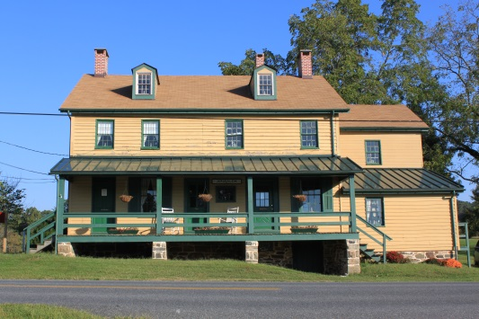

The General Store, Civil War Room and Gift Shop are open on Saturdays and Sundays from 1 p.m. to 4 p.m. Learn about the village’s connection to the Civil War, step into a 1930s general store, and browse our gift shop for a variety of souvenirs including items made by our own blacksmiths.

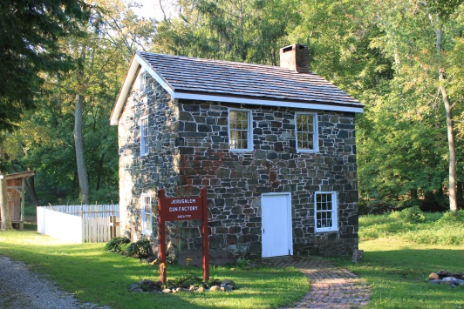

The Miller’s House (a.k.a. “the gun shop”) is open on Sundays from 1 p.m. to 4 p.m. Watch Living History interpreters demonstrate hearth and open fire cooking, gardening, sewing or other activities of daily life in Colonial times.

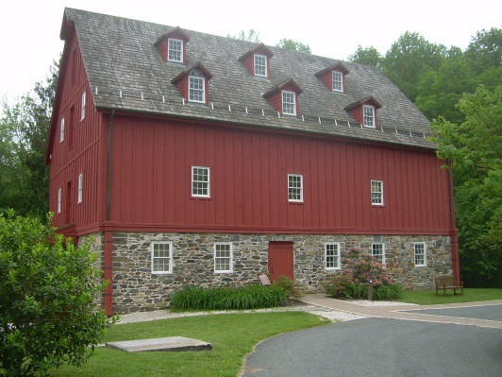

The Grist Mill (Visitor Center and Museum) is open on Saturdays and Mondays from 10 a.m. to 4 p.m., Sundays from 1 p.m. to 4 p.m., and Thursdays from 10 a.m. to 1 p.m. Learn about the village, explore our artifacts, and see how a 1772 grist mill operated.

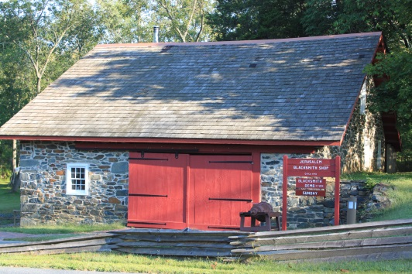

The Blacksmith Shop is open on most Saturdays and Sundays, from 1 p.m. to 4 p.m. See the forge in operation as our blacksmiths demonstrate their trade.

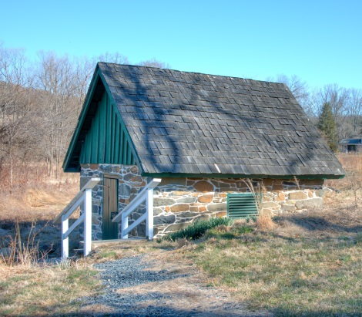

The Springhouse was used to store perishable dairy products and other food items. A spring maintains a year-round temperature of 56 degrees. The Springhouse is open on Saturdays and Sundays from 1 p.m. to 4 p.m.

Thanks to our Sponsors

We are sincerely grateful to our sponsors for their generosity, enthusiasm, and belief in our mission! We encourage all of our visitors to patronize our sponsors’ quality services and products. Please let them know that you saw their ad in this newsletter, and that you visited or contacted them because of their support to Jerusalem Mill. To inquire about sponsoring our many activities and events, e-mail us at jerusalemmill@yahoo.com !

Welch Mechanical Designs, LLC
Designers and manufacturers of high-quality, high-precision optical systems for commercial, military and scientific applications.
1200 Technology Drive, Suite N
Aberdeen, MD 21001 410-698-3024
https://www.wmdllc.com/

Sunshine Grille Bistro and Catering
Greek and American cuisine in a casually elegant atmosphere.
12607 Fork Road, Fork, MD 21051
410-592-3378

Wirtz & Daughters Garden Center
Visit us or use our delivery service for mulch, sand, soil, or stone products.
12140 Pulaski Highway, Joppa, MD 21085
410-335-1278 wirtz.kellyb@gmail.com
www.wirtzanddaughters.com

Walter G. Coale, Inc.
New Holland tractors, Mahindra tractors, Lawn care equipment, trailers and snow removal equipment for sale
2849 Churchville Rd, Churchville, MD, 21028 410-838-3500
ray@waltergcoale.com
www.waltergcoale.com

Mr. David Marks
Baltimore County Councilman
400 Washington Ave.
Towson, MD 21204
410-887-3384
davidmarks@verizon.net

It’s All Fun & Games Day Camp
Everything a camp should be!
Located in the Valleybrook Country Club
1810 Valleybrook Drive, Kingsville, MD, 21087 410-879-4460

Bel Air Dental Care
2300 Belair Road, Fallston, MD 21047
410-879-8424
www.belairdental.com

Harry and Scott Sanders
Long and Foster Realtors
Bringing a heritage of quality to Baltimore and Harford County real estate.
12514 Jerusalem Road, Kingsville, MD, 21087
www.come2md.com
410-515-7400

Lassahn Funeral Home
Heather Lassahn
11750 Belair Rd, Kingsville, MD 21087
410-665-2000
hlassahn@lassahnfuneralhomes.com
www.lassahnfuneralhomes.com

Feild Family Dentistry
Gentle Dental for the Whole Family
Drs. Paul & Matt Feild, DDS, PA
12619 Harford Road, Fork, MD 21051
410-592-5420
pefdds@aol.com
www.feildfamilydentistry.com

Yox’s Yard
Small engine and lawn equipment maintenance
12210 Pulaski Hwy., Bldg C
Joppa, MD 21085 410-977-5511
Yoxs.Yard@gmail.com

First Home Mortgage Corp.
Ann E. Parlang
5355 Nottingham Drive, Suite 115
Baltimore, MD 21236
apalrang@firsthome.com
www.firsthome.com/loanofficers/ann
410-336-2667

Kingsville Auto Repair
Terry Heil
12116 Belair Rd., Kingsville, MD 21087
kingsvilleauto@comcast.net
www.kingsvilleautorepair.com
410-592-7172
G&M Automotive
George Majchrzak
11825 Belair Rd., Kingsville, MD 21087
gmajchrzak@gmautomotive.com
www.gmautomotive.com
443-622-9564

Corbin Fuel Co., Inc.
Greg Ensor
P.O. Box 689
Bel Air, MD 21014
www.corbinfuel.com

Alianiello Eye Care
Bob Alianiello
11824 Belair Rd.
Kingsville, MD 21087
drrga@yahoo.com
www.alianielloeyecare.com
410-593-9818

Brightview Senior Living – Perry Hall
9657 Belair Rd.
Nottingham, MD 21236
BrightviewPerryHall.com
410-529-1903

There’s room for your listing here!

To become a sponsor, send us an e-mail at jerusalemmill@yahoo.com or call us on
410-877-3560.

Our concert series is supported by a grant from the Maryland State Arts Council and the Harford County Cultural Arts Board.

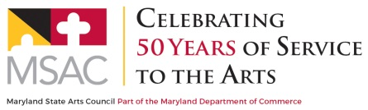
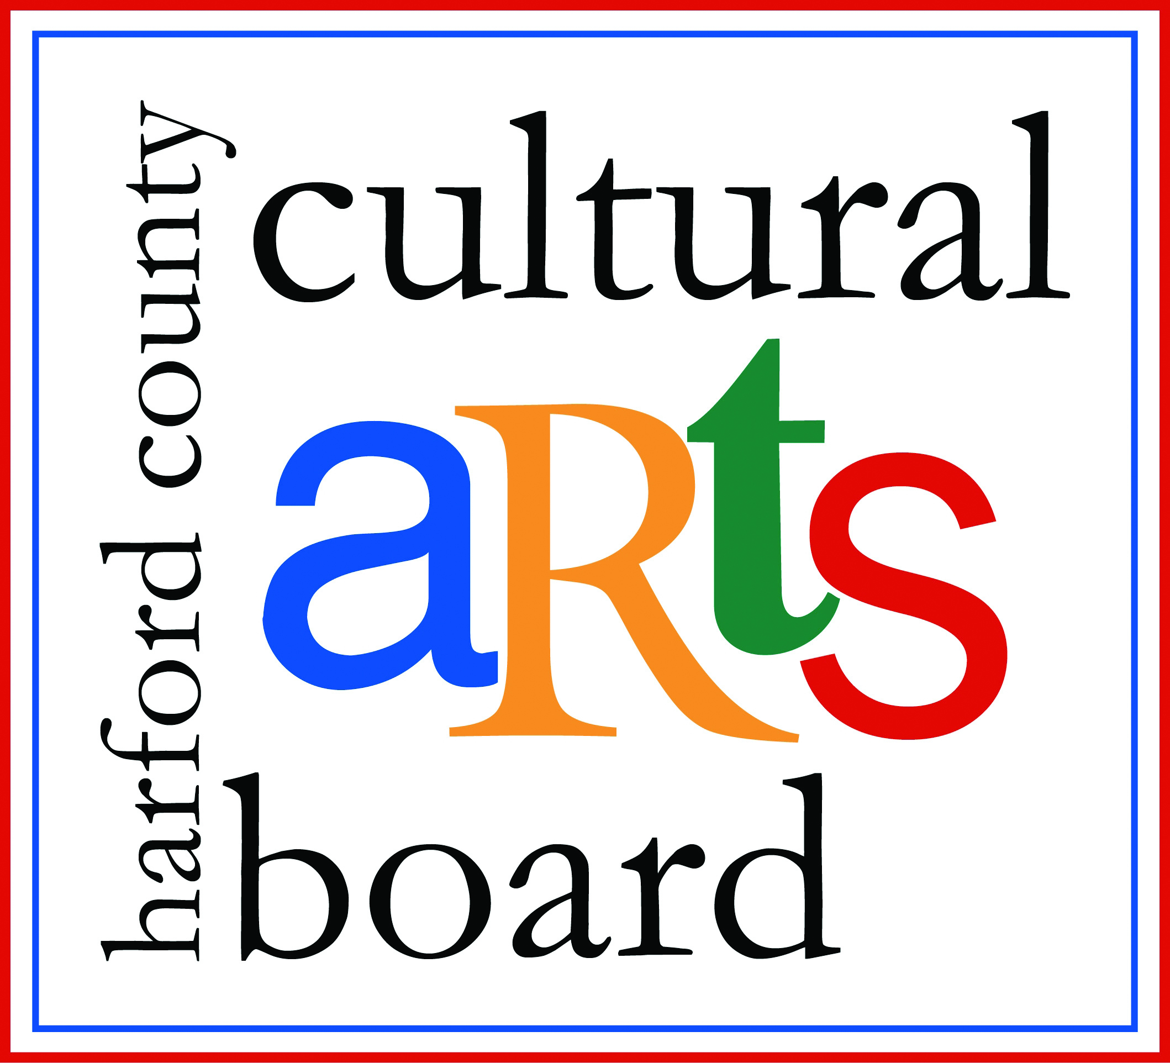

Special thanks to the Harford County Special Grants, Cultural Grants, and Office of Economic Development for their continued support!

To contact the newsletter editor, send an e-mail to jerusalem.mill.curator@gmail.com, or call the Visitor Center – Museum at 410-877-3560. To add another e-mail address to our subscription list, simply reply to the e-mail with a subject line of “subscribe” and enter the new e-mail address in the text box. To cancel your free subscription to the Gristmill Gazette, simply reply to the e-mail with a subject line of “unsubscribe”.

https://www.girlscouts.org/en/our-program/highest-awards.html
“Gunpowder Monthly Meeting." Gunpowder Monthly Meeting, Maryland State Archives, Annapolis, MD, Collection #: MSA SC 2980, Microfilm Reel: SCM 627-1. Microfilm.

