The Gristmill Gazette
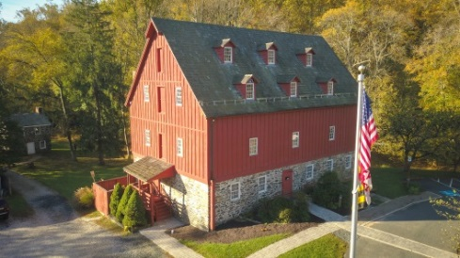
Jerusalem Mill Village
News & Notes
Fall 2019

2811 Jerusalem Rd., Kingsville, MD www.jerusalemmill.org 410-877-3560

Upcoming Events

All activities are in the village, unless otherwise indicated.

Saturday, October 12th, 9 AM ‘til noon: Second Saturday Serve Volunteer Day. Come help us with a wide variety of tasks throughout the village. All tools, materials, equipment and protective gear will be provided. We’ll meet on the porch of the General Store or in the Tenant House across the street from the store, depending on the weather. Everyone is invited.
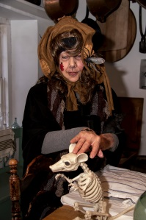
Saturday, October 19th: Fairy Tales to Scary Tales and Family Haunted Trail. Halloween activities for all ages. Family activities (e.g. face painting, scarecrow making, treats, scavenger hunt, etc.) will occur from 1 PM to 4 PM. The haunted trail will be open until 8 PM. DONATIONS NEEDED: old long sleeve shirts and long pants to be used in scarecrow making. You can drop off donated items at the Jerusalem Mill Visitor Center on Saturdays or Mondays between 10 AM and 4 PM, on Sundays between 1 PM and 4 PM, or by calling the Visitor Center on 410-877-3560 to make special arrangements.

Saturday, November 9th, 8 AM to 2 PM: Semi-annual Yard Sale. We’ll have a wide variety of household goods, books, DVDs, tools, equipment, toys, hardware, supplies, etc. If you have any items to donate, please call the Visitor Center at 410-877-3560 to arrange for drop-off, or simply bring them on the 9th (no chemicals or clothing). Most items in the yard sale will not be pre-priced. Take whatever you want, and we ask that you make a donation of cash in whatever amount you think is appropriate.

Saturday, November 9th, 9 AM ‘til noon: Second Saturday Serve Volunteer Day. Come help us with a wide variety of tasks throughout the village. All tools, materials, equipment and protective gear will be provided. We’ll meet on the porch of the General Store or in the Tenant House across the street from the store, depending on the weather. Everyone is invited.

Saturday, November 9th, 1 PM to 4 PM. Animal Rescue Expo.

Friday, December 6th, 8:30 AM to 11 AM: Gunpowder Falls State Park Volunteer Appreciation Pancake Breakfast in the Blacksmith Shop and the tent adjacent to it. All regular volunteers for the park and Jerusalem Mill Village are invited to enjoy a breakfast cooked by the park staff.

Sunday, December 8th, 1 PM to 4 PM: Christmas in the Village. Come see the village decorated in traditional colonial style, and hear about the Colonial Christmas traditions.

Monday, December 9th through Sunday December 29th, times vary: Holiday Train Garden at the Jacksonville Senior Center, featuring part of Jerusalem Mill Village. See article below.

Saturday, December 14th, 9 AM ‘til noon: Second Saturday Serve Volunteer Day. Come help us with a wide variety of tasks throughout the village. All tools, materials, equipment and protective gear will be provided. We’ll meet on the porch of the General Store or in the Tenant House across the street from the store, depending on the weather. Everyone is invited.

Details on all of our events are available on our web page at www.jerusalemmill.org or the Jerusalem Mill FaceBook page.
Jerusalem Mill Village in Miniature

The Jacksonville Senior Center presents their annual Holiday Christmas Garden, from December 9th through December 29th. A special feature this year will include portions of the Jerusalem Mill Village, in miniature and to scale. You can view the model railroad at the Jacksonville Senior Center at 3605A Sweet Air Road, Phoenix, MD 21131, just 12 miles from the village! There is no admission fee, although donations will be greatly appreciated. The Holiday Train Garden will be open to the public as follows:

December 9th through 13th, 16th through 20th, 23rd, 26th and 27th, from 11 AM until 3 PM.
December 14th, 15th, 21st, 22nd, 28th, and 29th, from 10 AM until 4 PM.
Historic Anniversary

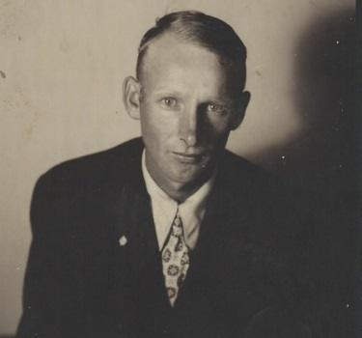
75 Years ago on November 28th, Dennis Whitt sold 11 acres within Jerusalem Mill Village back to Harry Pyle. Interestingly, Dennis Whitt bought the same 11 acres from Harry Pyle on July 11th of that same year (1944). Transcribed versions of both transactions are on file with Maryland Land Records, as part of the Harford County Circuit Court collection. Both transactions were in the amount of $10.00, a curiously small amount of money, even for the era shortly after The Great Depression. To put that price in perspective, the 11 acres was part of 25 acres that William A. Wilson purchased in 1900 for a total of $3,000. It appears that the 11 acres included the grist mill, and perhaps the blacksmith shop and miller’s house, however we need to work with some survey experts to confirm the exact property boundaries. According to Dennis Whitt’s son, Alfred, Dennis worked at the mill before purchasing it. Alfred also reports that Dennis “had hundreds of laying hens on the top floor of the mill” and that Alfred and his sister used to gather the eggs. We know that Dennis Whitt entered military service in May 1945, so that might explain why he chose to sell the property back to Harry Pyle. Curiously, the National Register of Historic Places attributes ownership in 1944 only to Harry Pyle, possibly due to the short duration of ownership by Dennis Whitt. We’ll continue our research in an attempt to discover the whole story and to verify the property lines.

We want to thank Alfred Whitt for donating several original documents pertaining to the Whitt ownership and more. Included in those original documents is 1) a deed for the purchase of the 11 acres from Harry Pyle, dated June 30, 1944, 2) a receipt for $3.50 for the mortgage, dated July 1, 1944 (the date the deed was recorded), 3) a handwritten acknowledgment of payment “in full for all amounts due”, signed by Harry S. Pyle, 4) a handwritten note from L. H. Luckado to “Mr. Dennis”, regarding “a new idea” to use one of the millstones to produce gasoline (probably ethanol). The note is in an envelope simply addressed to “Mr. Dennis, care of Jerusalem Mill, Harford County MD”, and is postmarked Dec 27 1944, with two one-cent postage stamps, 5) the photo of Dennis Whitt shown here, and 6) an unrelated full page article in the June 16 1967 edition of The Sun, regarding a “Historical Tour Planned” of Jerusalem Mill and other nearby historical locations.
In the Spotlight:

Jerusalem Mansion

Across the street from the village’s small paved parking lot is a large rectangular building that is situated with the smaller sides as the north and south walls, and the longer sides facing east and west. This building is identified as the “Jerusalem House” on the National Register of Historic Places Inventory – Nomination Form, but the staff at Jerusalem Mill fondly refers to it as the Lee-Pullen house, nick-named after the two families who occupied the residence the longest. The Friends of Jerusalem Mill just recently took possession of the 4,606 s.f., 20-room mansion as part of our long-term lease of the village. Our Winter 2019 edition of the Gristmill Gazette included an article of the most recent resident, Dr. Phyllis Pullen, who passed away a year ago. A future Gazette article will detail the history of the house, but we want to take this opportunity to provide you with an update on our current plans regarding the mansion.
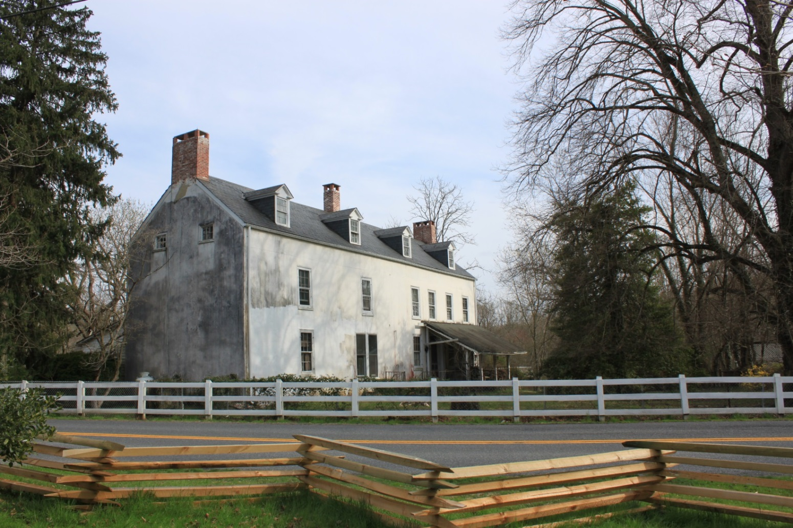

“Jerusalem House” (or Lee-Pullen Mansion), April 2019

After adding the house to our inventory, our first action was to hire an architect who specializes in historic structures and preservation. This architect will identify the specific features of historical significance, provide facts and theories on how and when it was constructed, and make recommendations on restoration, repairs and potential uses. This study is a crucial step in applying for potential grants to accomplish the more expensive repairs and major restorations. A preliminary analysis of the structure has created some intriguing questions and theories. For example, there is a 4” to 5” difference in the width of the building on the north wall versus the south wall. Why? There is also a step down from the center section of the house to the north end on two floors, but not on the upper floor. And on the exterior of the house one can clearly see a joint line above the second floor. These features seem to support the theory that the house was originally two separate buildings that were later connected, and the roof line was raised to add a third floor. This theory is further supported by the fact that the subfloor joists in the center section of the house run perpendicular to the joists on the north and south ends, and the exterior walls of the top floor are wood-framed, as opposed to the stone walls of the lower floors.

In the basement of the building there is a large arch-covered area that would be typical of a spring house, but no evidence as to its actual purpose. Perhaps it served as a root cellar. On the opposite wall from the arch is an inverted stone support, tapering down from the ceiling to the floor. On the floors above, the floor planks are cut on a diagonal, apparently patched in as a later modification. The tapered support and floor planks suggest that at one time there were corner fireplaces on the two floors above. On the south wall of the basement one can clearly see the stone patchwork enclosing a basement entrance that once existed on the south wall, perhaps serving as an entrance to the basement root cellar.

We hope to be able to restore and preserve at least portions of the mansion for historic interpretation and make it available to the public. We want to preserve Doctor Pullen’s office and waiting room (mid-1900s), but restore the kitchen (with open-hearth fireplace) and dining room to the Colonial period. Your memberships, sponsorships, and generous donations will help us accomplish our mission to restore, preserve and present this mansion and the other historic structures in the village.
Great Gift Ideas
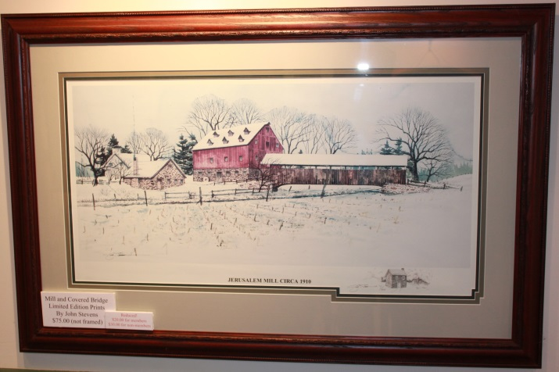

Here’s a great idea for a holiday gift for someone who loves local history. We have limited edition prints of Jerusalem Mill circa 1910, by artist John Stevens. The 16 ½” x 32” print shows the former Jerusalem Covered Bridge, the grist mill, blacksmith shop and wheelwright shop in the foreground, and a portion of the Lee Mansion in the background. Originally valued at $75.00, you can now get this beautiful print with a donation of only $10.00, while supplies last. Matte and frame are not included.

We also have limited edition prints called “Christmas at the Gun Shop” in Jerusalem Village, by artist Jackie Miller. The 14 3/8” high x 19” wide print shows the building behind the mill after a December snowfall. The building at various times served as a wood shop producing gun stocks, a cooperage producing barrels, a cannery, and a house for a succession of families. In fact, one of our docents, David Ewing, was born in that house.
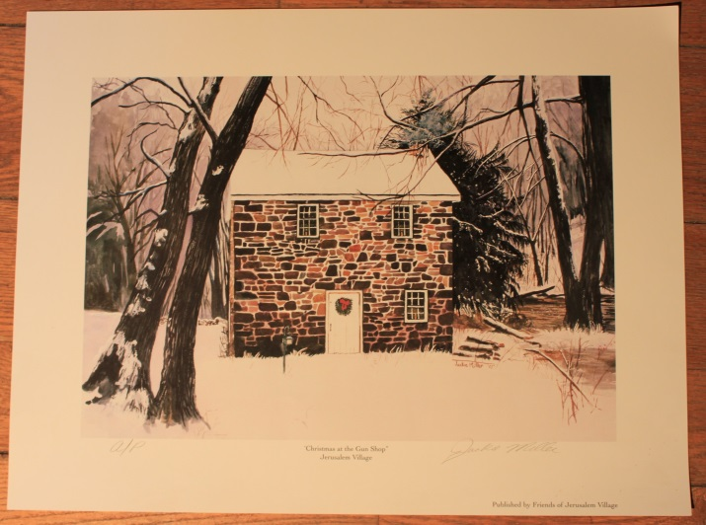

Originally valued at $70.00, you can now get this beautiful print with a donation of only $5.00, while supplies last. Matte and frame are not included.
All of the proceeds from the donations help in the restoration, maintenance and operations of the Jerusalem Mill Village.

These prints are available in the Visitor Center – Museum and in the General Store gift shop. Stop in the General Store gift shop to see a variety of other gift items.
In Memoriam

With much sadness, the Gunpowder Falls State Park staff announces the loss of a much-treasured and nearly life-long member of their family, retired Maintenance Supervisor Lance Langrehr. A memorial service has been scheduled for October 12th at St. Stephens Catholic Church, 8030 Bradshaw Road, Kingsville, MD 21087. There will be a celebration of life immediately following the service, at the Gum Pavilion in the Hammerman Area of the park, 7200 Graces Quarters
Middle River, MD 21220. Friends, family and co-workers are invited to share memories of Lance at the gathering.
We Need Your Help

Because The Friends of Jerusalem Mill is a non-profit charitable organization, we rely on generous donations of time and money from our many volunteers and donors to accomplish our mission of preserving and presenting local history. Let us know if you have some time to spare and can help us continue our mission. Here’s just a sample of some of the volunteer opportunities:

Docents: Greet visitors and guide them through the visitor center/museum, the general store, or the Civil War Room. Provide information about the history and operation of the village and answer questions about the park. No prior knowledge of the village history or details about the park is required. Our Volunteer Handbook has all of the information you’ll need.

Special events: Plan and organize. Collect tickets/admission, set up chairs, tables, canopies, etc., direct parking, assist pedestrian crossings, guide visitors, tear-down, etc. This can be a year-round commitment or a one-event commitment.

Research/Curatorial Assistants: Identify and inventory artifacts; perform various research projects online, at historical societies and archives; create displays, etc. Focus areas include genealogy, architecture, archeology, history and sociology.

Living History Interpreters: Wear era-appropriate attire, share knowledge of various aspects of life in the 18th and 19th century. Most immediate need is for a carpenter/woodworker, toy demonstrator, cooper, tinsmith, gardeners/farmers, colonial cooks, tour guides.

Grant writers: Help us manage our grant program by preparing grant applications for a wide variety of projects and purchases. Maintain a calendar of deadlines to ensure we don’t miss an opportunity or obligation. This function can mostly be performed at home or office!
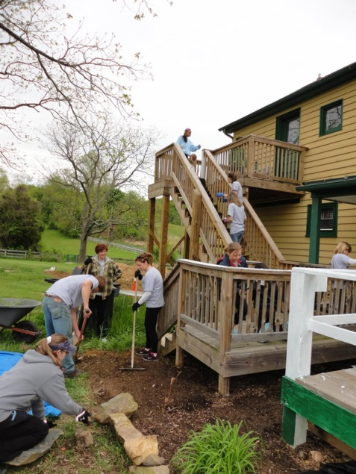

Village Maintenance and Repairs: Second Saturday Serve is a year-round, monthly event open to volunteers of all ages, on the second Saturday of every month, from 9:00 a.m. until noon, to perform a wide variety of tasks. Just show up and we’ll put you to work!

Web Master: Help us keep our web pages up-to-date.

Trail maintenance: Hike the wooded trails of the Gunpowder Falls State Park Central Area and pick up trash, remove debris from the trails, trim overgrowth, and report downed trees and other hazards to the park office.

Donations: Financial contributions can be made through membership, business sponsorship, renovation or maintenance fund contributions (cash, check or through PayPal at https://www.paypal.me/jerusalemmill), or by selecting the Friends of Jerusalem Mill as the charity of choice when you purchase through AmazonSmile (smile.amazon.com).

You can get more information on all of these opportunities at www.jerusalemmill.org, or e-mail us at jerusalemmill@yahoo.com, or call us on 410-877-3560.

To contact the newsletter editor, send an e-mail to jerusalem.mill.curator@gmail.com, or call the Visitor Center – Museum at 410-877-3560. To add another e-mail address to our subscription list, simply reply to the e-mail with a subject line of “subscribe” and enter the new e-mail address in the text box. To cancel your free subscription to the Gristmill Gazette, simply reply to the e-mail with a subject line of “unsubscribe”.

Jerusalem Mill Village Living History Program, 2019
All times listed above are subject to the availability of volunteers.

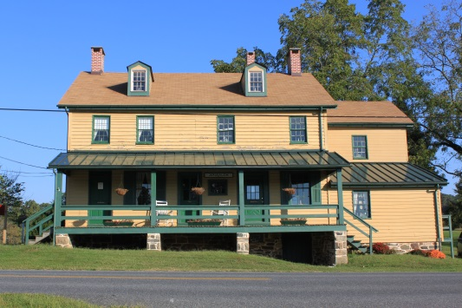

The General Store, Civil War Room and Gift Shop are open on Saturdays and Sundays from 1 p.m. to 4 p.m. Learn about the village’s connection to the Civil War, step into a 1930s general store, and browse our gift shop for a variety of souvenirs including items made by our own blacksmiths.

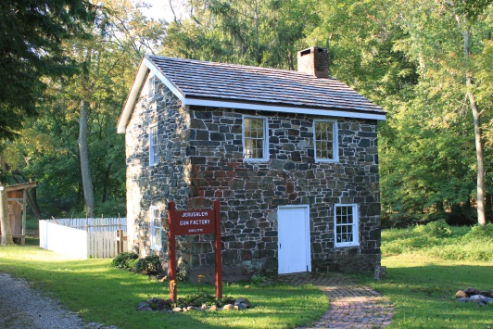

The Miller’s House (a.k.a. “the gun shop”) is open on Sundays from 1 p.m. to 4 p.m. Watch Living History interpreters demonstrate hearth and open fire cooking, gardening, sewing or other activities of daily life in Colonial times.

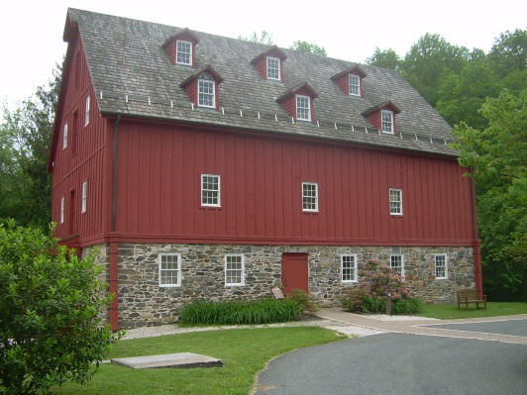

The Grist Mill (Visitor Center and Museum) is open on Saturdays and Mondays from 10 a.m. to 4 p.m., and Sundays from 1 p.m. to 4 p.m. Learn about the village, explore our artifacts, and see how a 1772 grist mill operated.

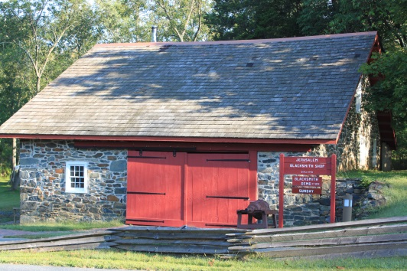

The Blacksmith Shop is open on the second Saturday of every month, from 1 p.m. to 4 p.m. See the forge in operation as our blacksmiths demonstrate their trade.

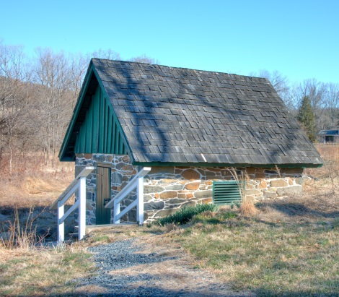

The Springhouse was used to store perishable dairy products and other food items. A spring maintains a year-round temperature of 56 degrees. The Springhouse is open on Saturdays and Sundays from 1 p.m. to 4 p.m.

Thanks to our Sponsors

We are sincerely grateful to our sponsors for their generosity, enthusiasm, and belief in our mission! We encourage all of our visitors to patronize our sponsors’ quality services and products. To inquire about sponsoring our many activities and events, e-mail us at jerusalemmill@yahoo.com !

Welch Mechanical Designs, LLC
Designers and manufacturers of high-quality, high-precision optical systems for commercial, military and scientific applications.
1200 Technology Drive, Suite N
Aberdeen, MD 21001 410-698-3024
https://www.wmdllc.com/

Sunshine Grille Bistro and Catering
Greek and American cuisine in a casually elegant atmosphere.
12607 Fork Road, Fork, MD 21051
410-592-3378

Wirtz & Daughters Garden Center
Visit us or use our delivery service for mulch, sand, soil, or stone products.
12140 Pulaski Highway, Joppa, MD 21085
410-335-1278 wirtz.kellyb@gmail.com
www.wirtzanddaughters.com

Walter G. Coale, Inc.
New Holland tractors, Mahindra tractors, Lawn care equipment, trailers and snow removal equipment for sale
2849 Churchville Rd, Churchville, MD, 21028 410-838-3500
ray@waltergcoale.com
www.waltergcoale.com

Mr. David Marks
Baltimore County Councilman
400 Washington Ave.
Towson, MD 21204
410-887-3384
davidmarks@verizon.net

It’s All Fun & Games Day Camp
Everything a camp should be!
Located in the Valleybrook Country Club
1810 Valleybrook Drive, Kingsville, MD, 21087 410-879-4460

Bel Air Dental Care
2300 Belair Road, Fallston, MD 21047
410-879-8424
www.belairdental.com

Harry and Scott Sanders
Long and Foster Realtors
Bringing a heritage of quality to Baltimore and Harford County real estate.
12514 Jerusalem Road, Kingsville, MD, 21087
www.come2md.com
410-515-7400

Lassahn Funeral Home
Heather Lassahn
11750 Belair Rd, Kingsville, MD 21087
410-665-2000
hlassahn@lassahnfuneralhomes.com
www.lassahnfuneralhomes.com

Feild Family Dentistry
Gentle Dental for the Whole Family
Drs. Paul & Matt Feild, DDS, PA
12619 Harford Road, Fork, MD 21051
410-592-5420
pefdds@aol.com
www.feildfamilydentistry.com

Yox’s Yard
Small engine and lawn equipment maintenance
12210 Pulaski Hwy., Bldg C
Joppa, MD 21085 410-977-5511
Yoxs.Yard@gmail.com

First Home Mortgage Corp.
Ann E. Parlang
5355 Nottingham Drive, Suite 115
Baltimore, MD 21236
apalrang@firsthome.com
www.firsthome.com/loanofficers/ann
410-336-2667

Kingsville Auto Repair
Terry Heil
12116 Belair Rd., Kingsville, MD 21087
kingsvilleauto@comcast.net
www.kingsvilleautorepair.com
410-592-7172
G&M Automotive
George Majchrzak
11825 Belair Rd., Kingsville, MD 21087
gmajchrzak@gmautomotive.com
www.gmautomotive.com
443-622-9564

Corbin Fuel Co., Inc.
Greg Ensor
P.O. Box 689
Bel Air, MD 21014
www.corbinfuel.com

Alianiello Eye Care
Bob Alianiello
11824 Belair Rd.
Kingsville, MD 21087
drrga@yahoo.com
www.alianielloeyecare.com
410-593-9818

Brightview Senior Living – Perry Hall
9657 Belair Rd.
Nottingham, MD 21236
BrightviewPerryHall.com
410-529-1903

There’s room for your listing here!

To become a sponsor, send us an e-mail at jerusalemmill@yahoo.com or call us on
410-877-3560.

Our concert series is supported by a grant from the Maryland State Arts Council and the Harford County Cultural Arts Board.

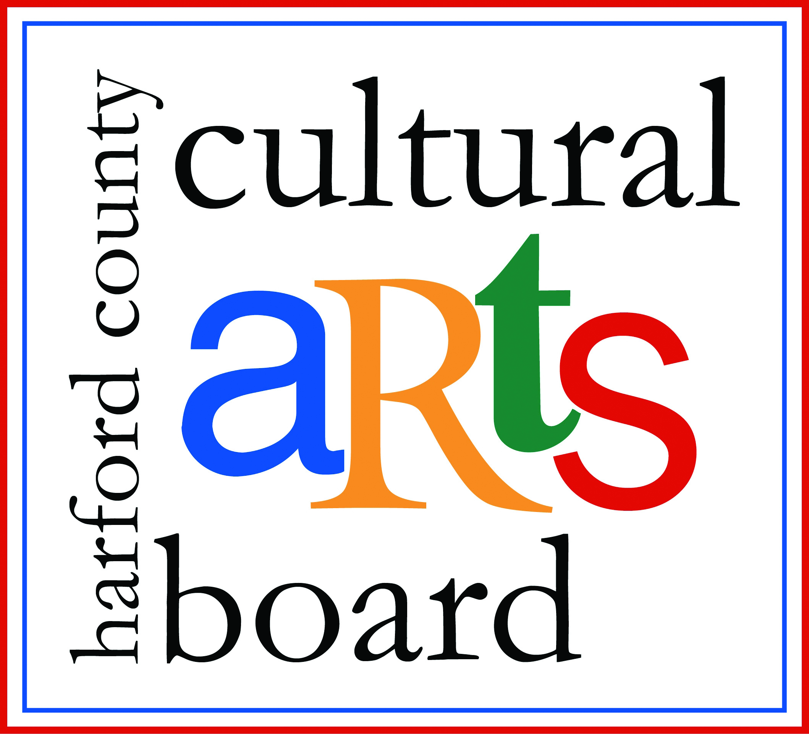

Special thanks to the Harford County Special Grants, Cultural Grants, and Office of Economic Development for their continued support!

