The Gristmill Gazette
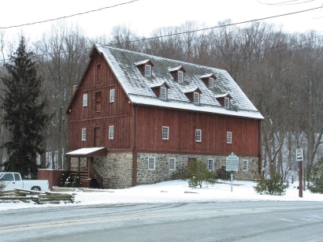
Jerusalem Mill Village
Special Holiday Edition
December 2018

Christmas from the Past
By Jessica Miller

The Christmas season is almost over, with many homes having been decorated right after Thanksgiving! Decorations are on display, gifts have been exchanged with friends and family, music is being played everywhere, and holiday events are still taking place. It’s a festive time of year, one filled with long-standing traditions that we often don’t think twice about. Many of the Christmas traditions that we hold dear today had their beginnings over 150 years ago during what is known as the Victorian era (1837-1901). Because Jerusalem Mill Village was in operation during this period in history, we at the village have put together an exhibit that shares the history of the Christmas traditions that had their origins during the Victorian era and have continued to this day.

The original plan for the exhibit was to be centered around colonial Christmas traditions, similar to Colonial Williamsburg’s beautiful wreaths and decorations that are on display there every holiday season. But after further research, we discovered that Williamsburg’s decorative displays aren’t accurate for the colonial time period, historically speaking. Decorations during colonial times were even more simplistic, as were other Christmas traditions. For instance, fruit would not have been a part of decorating, as it would’ve been seen as a waste of produce and susceptible to rotting and being eaten by wild animals. The decorations that we now associate with

Colonial Williamsburg had their beginning in the 1930s, as a part of new Christmas decorating trends that began in American homes during that time (Williamsburg’s website admits to the misconception). In Jerusalem Mill’s grist mill we decided to skip a couple of decades past the colonial period and focus on a Christmas exhibit that represented the Victorian era, since there is such a strong connection between the traditions then and the traditions today.

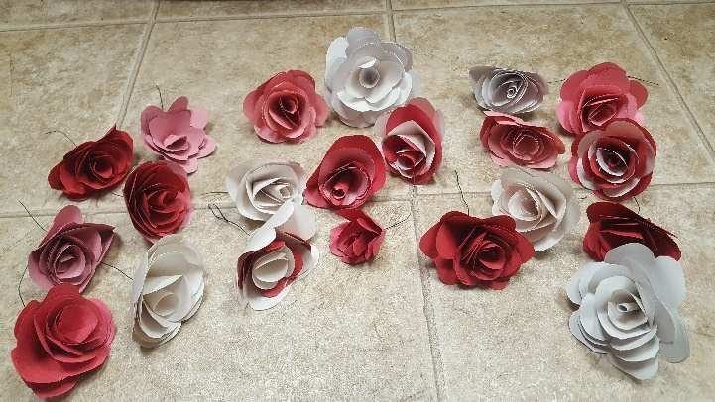
Roses, hand-made by our volunteers

The main focus of the exhibit is a Christmas tree that’s covered in hand-made decorations that represent what would’ve been on a Victorian Christmas tree. One of the main decorations on the tree is an assortment of beautiful paper roses, all handmade by a wonderful group of volunteers during Jerusalem Mill’s Second Saturday Serve earlier in November. There is also an assortment of cards hanging on the tree, each with a Victorian design on the front, and a Christmas fun fact inside! There is be a range of fun facts about Christmas traditions within these cards, including information about carols, food and drink, decorations, party games, the impact of Charles Dickens’ famous story, A Christmas Carol, and some rather interesting traditions that we’re probably glad went out of style!

This special exhibit was set up in time for Jerusalem Mill’s “Christmas in the Village” event on December 9th. It will remain set up until mid-January, so as many people can come and enjoy it as possible. We hope you’ll be able to drop by and pay us a visit to learn about the Christmas traditions of the past!
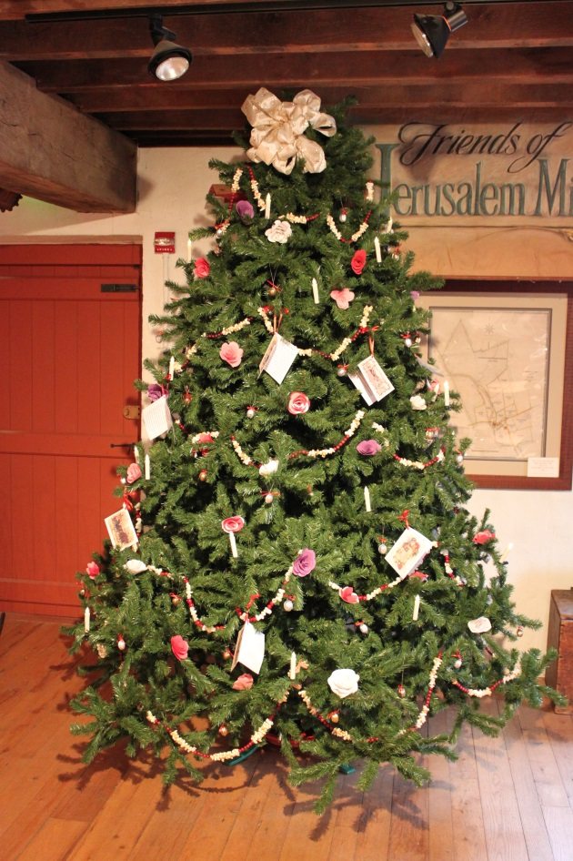

Editor’s note: Special thanks to Jessica Miller for her in-depth research on Victorian decorations, for personally making the walnut decorations and fun-facts cards, for leading the team of volunteers who made the roses, and for decorating the tree. Thanks also to Jean Rider for donating the beautiful tree, to Laura Franks for donating the popcorn & cranberry garland, and to John Gontrum for assembling the tree. It was a true team effort!
Victorian Christmas Facts
By Jessica Miller and Rich Albright

- Charles Dickens’ A Christmas Carol was written in 1843, in just six weeks. Not only did the novel save Dickens from financial ruin, but it also helped inspire and revive several Christmas traditions, including family gatherings, special dinners, and charitable giving.
- Christmas cards were first invented and printed in England in the 1840s, but didn’t catch on in America until the 1870s.
- Blindman’s Bluff was a popular Victorian Christmas game. A blindfolded player tried to catch and identify other people in the room.
- “Jingle Bells”, written by James Lord Pierpont, was published in 1857 under the title “One Horse Open Sleigh”.
- “O Holy Night” was composed by Adolphe Adam in 1847. The lyrics came from a poem written by French wine merchant and poet Placide Cappeau.
- Although the melody for “Deck the Halls” dates back to the 16th century, the English lyrics, written by the Scottish musician Thomas Oliphant, date to 1862.
Upcoming Events

January 1st – First Day Hike. Start times
are 10 a.m. and 12 p.m. (Please not
time correction from our Fall edition).
Meet in the meadow next to the
Blacksmith Shop. Easy to moderate
difficulty. Approximately 2 ½ miles round
trip (allow at least an hour).

January 12th – Second Saturday Serve
volunteer day, 9 a.m. until noon. Gather
in the Tenant House at the corner of
Jerusalem Rd. and Jericho Rd.
Volunteers of all ages are welcome.

Details on all of our events will be available on our web page at www.jerusalemmill.org.

We close the year, and this edition of the Gristmilll Gazette, with photos of our 2018 Christmas in the Village on December 9th.
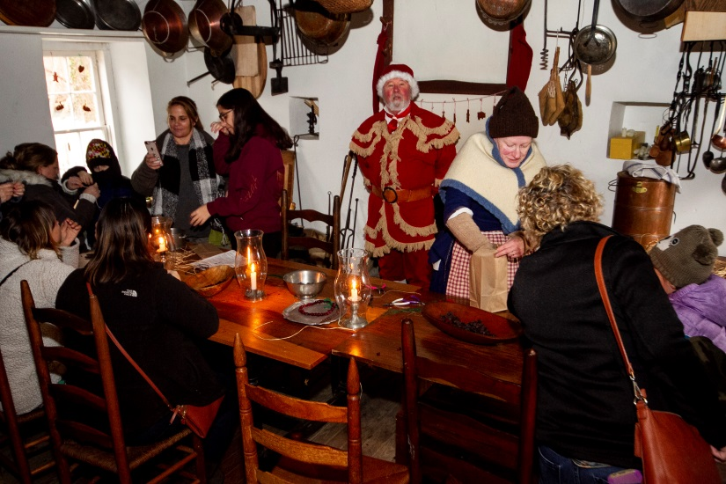
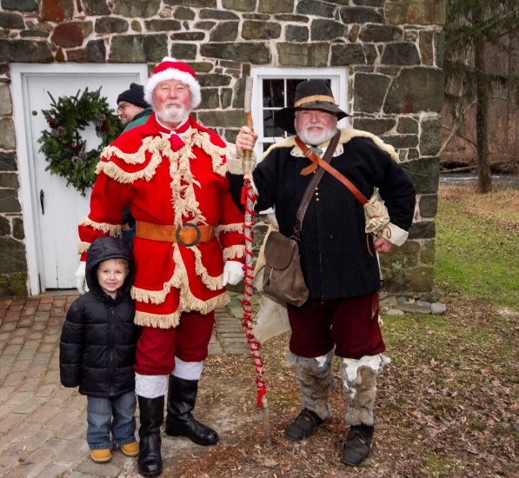

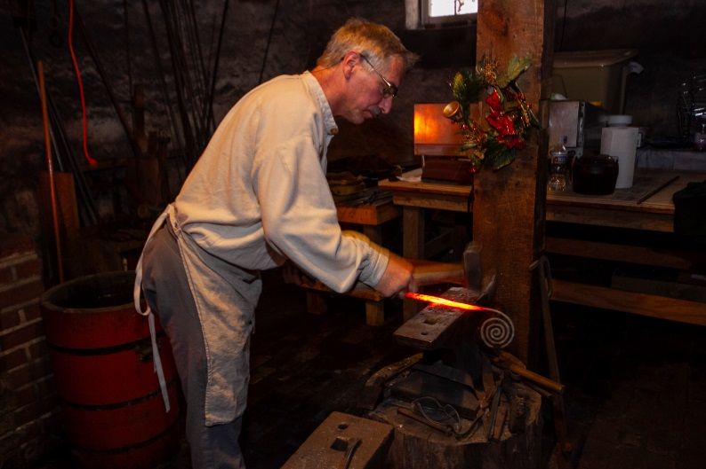
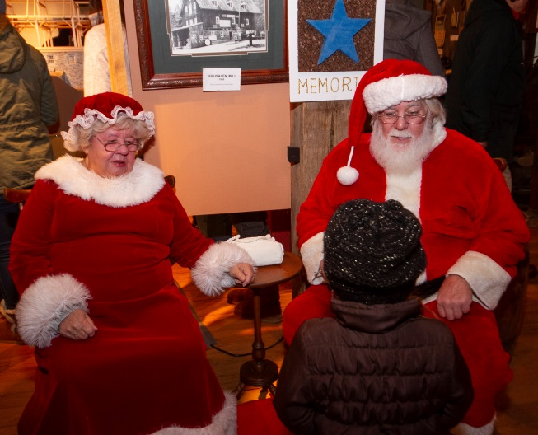

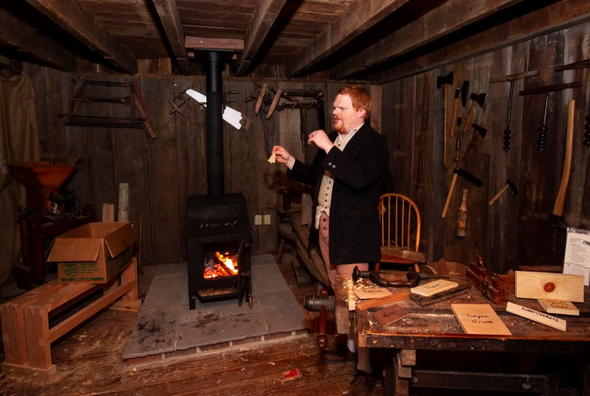
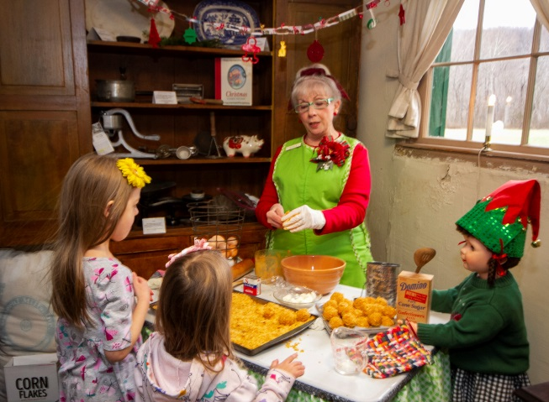

Photos were taken by Jack Benesch.

The Friends of Jerusalem Mill wish you a happy, healthy and prosperous New Year!

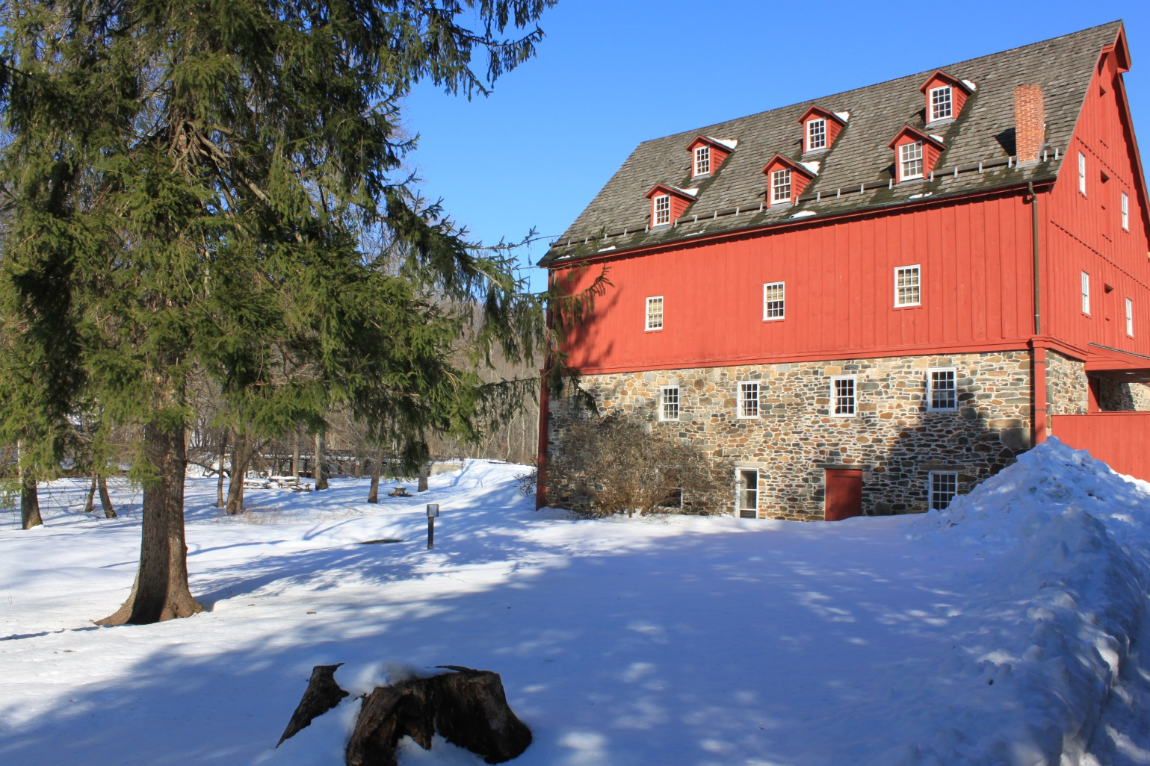

Look for our regular Winter edition of the Gristmill Gazette in January.

To contact the newsletter editor, send an e-mail to jerusalem.mill.curator@gmail.com, or call the Visitor Center – Museum at 410-877-3560.

